Actors

The target user for the web application is anyone inside the university ecosystem: students, professors and any type of academic staff. Although the website is available for use by every organ in the university, the permissions and restrictions applied to each user are going to be different especially based on their knowledge and skill. In order for the less experienced users to be able to do simple tasks such as viewing a specific port in a particular classroom, one of our main purposes was to make our user interface as friendly as possible.

(Explain in the future how our interface was “newbie friendly”).

Our aim was not only to develop a web application that allowed users with little to no knowledge in the area to be able to check and monitor the network in the campus but also for experts in the department to be able to easily change components in the network with just a few clicks.

(*Add some other “basic” features our web app doesn’t have and why*)

The main actors are described in the following list:

- User type 0: User type 0 is able to be authenticated by the university’s IdP but has no permission to do anything else after the login. #TODO (complete after stic’s instructions)

- User type 1: User type 1 besides authentication, is able to see a specific port, check the specific port state and can also subscribe a port, by doing that, he’s able to get a notification every time the port state changes. This user type is going to be targeted for professors, since they usually only need information about the department they give lectures in, they have no need to see information about ports in other departments nor do they have the knowledge and/or permission to do more advanced configurations.

- User type 2: User type 2 is able to do everything in the website, he can do everything the user type 1 is allowed to, with no restrictions. He can activate and deactivate ports, configure VLANs and schedule commands. This type of user is designed for a STIC employee. They were the first users the app was suppose to target, this way, a user type 2 is able to do a lot of configurations and monitoring
- remotely without having to have full knowledge about the network.

Use Cases

The following image shows the Use-Case Model of the whole system. We can see what components are common between users and which of them are restricted to a specific type.

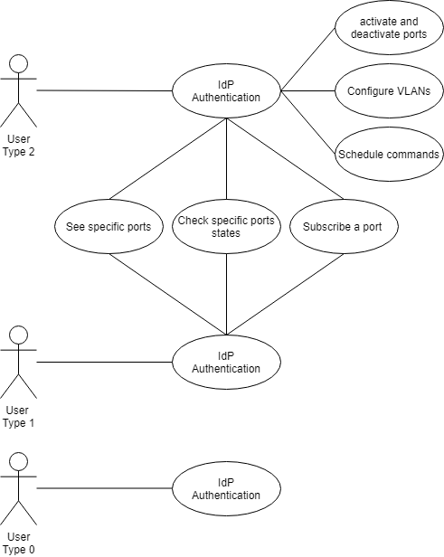

Diagrams

Domain Model

This diagram represent the relationship between this three class, Equipment, Department and User...

(diagrama incompleto)

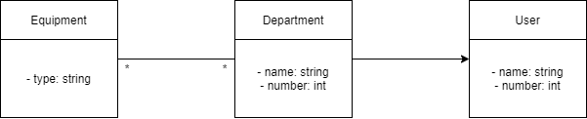

Physical Model

This diagram represents the physical architecture of the system, as well as the technology we are going to use in each layer. The diagram is grouped by devices that clients use to enjoy the app, devices that remain on the back-end, and devices used to host databases and APIs.
For the client layer, we are going to develop a web app in JavaScript, that will communicate with databases and cisco APIs through Django REST API. The logs will be in persistence data, and that consists of changes made by clients when using the app (we will be using non-relational database, mongo) and some data required to build the site, such as images (we are not sure if we will be using MySQL, but it will be something similar).

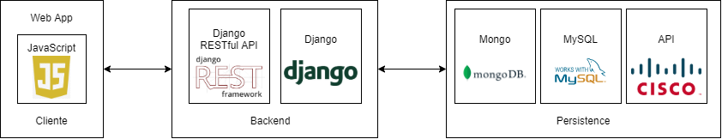

Technological Model

The next diagram represents essentially how our application will work. The app will be in a virtual machine hosted in UA, and it can be accessed by several clients. We will use Cisco APIs given by Stic and that will allow us to change UA’s network equipment.

